Activity 1 | What frustrations do you have around grading?
Visit the Padlet to record your response: https://tinyurl.com/gradingreimagined

Reflection | Your vision for grading
What do you wish grading could be for your students? What do you wish grading could be for you?

Notes | Five interrelated elements of specifications grading
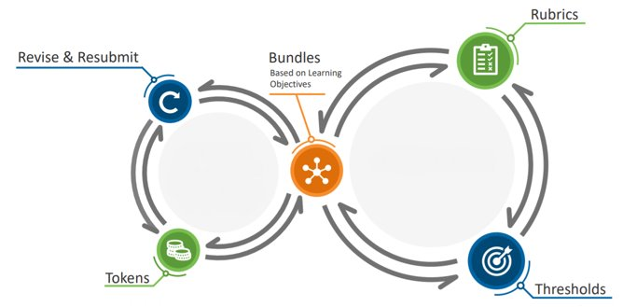

Activity 2 | Planning
Select one or more of the specifications grading characteristics to consider implementing. With your partner/small group, discuss how you could use specifications grading in your own course.
Possible questions to consider:
- How might you use this idea in your own assessment plan and grading?
- How can this idea help alleviate a grading frustration and/or move you closer to your vision for grading?

- Grading bundles
- Revise/resubmit
- Token economy
- Rubrics/Specifications
- Passing thresholds

Questions?
Note any questions you want to bring up to the full group after the breakout session.

Citations
Ring, J. ConfChem Conference on Select 2016 BCCE Presentations: Specifications Grading in the Flipped Organic Classroom. J. Chem. Educ. 2017, 94 (12), 2005–2006.
- The example for the core and advanced objectives configuration comes from here.

Howitz, W. J.; McKnelly, K. J.; Link, R. D. Developing and Implementing a Specifications Grading System in an Organic Chemistry Laboratory Course. J. Chem. Educ. 2021, 98 (2), 385–394.
- My work with colleagues from UCI in a chemistry lab course.

Blackstone, B.; Oldmixon, E. Specifications Grading in Political Science. Journal of Political Science Education 2019, 15 (2), 191–205.
- Specs grading in political science. A great description of some reasoning behind their design.

Carlisle, S. Simple Specifications Grading. PRIMUS 2019, 1–26.
- Two different examples of specs grading in math.

Martin, L. J. Introducing Components of Specifications Grading to a General Chemistry I Course. In Enhancing Retention in Introductory Chemistry Courses: Teaching Practices and Assessments; ACS Symposium Series; American Chemical Society: Washington, DC, 2019; Vol. 1330, pp 105–119.
- An example of a hybrid implementation and a full implementation of specs grading.

Sanft, K. R.; Drawert, B.; Whitley, A. Modified Specifications Grading in Computer Science: Preliminary Assessment and Experience across Five Undergraduate Courses. J. Comput. Sci. Coll. 2021, 36 (5), 34–46.
- Specs grading in computer science.

Katzman Shoshana D.; Hurst-Kennedy Jennifer; Barrera Alessandra; Talley Jennell; Javazon Elisabeth; Diaz Mary; Anzovino Mary E. The Effect of Specifications Grading on Students’ Learning and Attitudes in an Undergraduate-Level Cell Biology Course. J. Microbiol. Biol. Educ. 0 (0), e00200–e00221.
- Specs grading in biology.

McKnelly, K. J.; Morris, M. A.; Mang, S. A. Redesigning a “Writing for Chemists” Course Using Specifications Grading. J. Chem. Educ. 2021, 98 (4), 1201–1207.
- Specs grading in a writing course.

Fernandez, T.; Martin, K.; Mangum, R.; Bell-Huff, C. Whose Grade Is It Anyway?: Transitioning Engineering Courses to an Evidence-Based Specifications Grading System. In 2020 ASEE Virtual Annual Conference Content Access Proceedings; ASEE Conferences, 2020. https://doi.org/10.18260/1-2--35512.
- Specs grading in a selection of engineering courses (authors from GT).

Mendez, J. Standards-Based Specifications Grading in a Hybrid Course. In 2018 ASEE Annual Conference & Exposition; 2018.
- The example for the “all equal objectives” configuration comes from here.

Tsoi, M. Y.; Anzovino, M. E.; Erickson, A. H.; Forringer, E. R.; Henary, E. Variations in Implementation of Specifications Grading in STEM Courses. Georgia Journal of Science 2019, 77 (2).
- Many examples of specs grading across many STEM disciplines.

